Lesson 5 Demo 3: Create Replicated and Global Services

This section will guide you to:

* Create a replicated and a global service in Docker

**Step 1:** Create a replicated service with the *nginx* image

*sudo docker service create --name myweb --replicas 3 nginx*

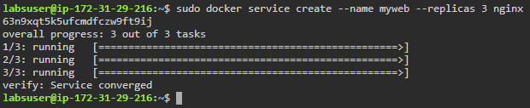

**Step 2:** Create a global service with the *alpine* image

*sudo docker service create *

*--name myservice *

*--mode global alpine top*

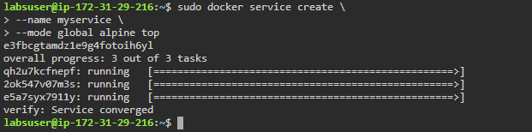

**Step 3:** List all the Docker services

*sudo docker service ls*

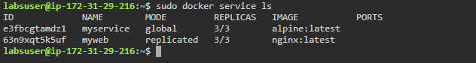

**Step 4:** Check the status of the global service i.e., **myservice**

*sudo docker service ps myservice*

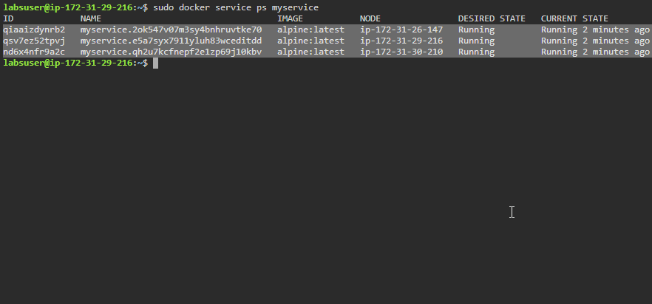

**Note:** Notice that the global service is running its instances on all the nodes of the swarm cluster.

**Step 5:** Check the status of the replicated service i.e., **myweb**

*sudo docker service ps myweb*

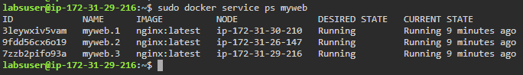

**Note:** Notice that the replicated service is running the service replicas on all the nodes of the swarm cluster.